Area under Curves

Our concentration in this Chapter is to find the area bounded/enclosed by curves with a general formula or with the help of definite integration.

Definition of Area:

The mathematical term 'area' can be defined as the amount of two-dimensional space taken up by an object. The use of area has many practical applications in building, farming, architecture, science, and even deciding how much paint you need to paint your bedroom. The area of a shape can be determined by placing the shape over a grid and counting the number of squares that the shape covers, like in this image:

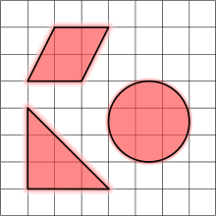

The area of many common shapes can be determined using certain accepted formulas. But it is not possible to determine the area of a zigzag region by normal formula. So in this case we calculate the area of such types of region by Integration.

In another way thinking:

Area is defined as the number of square units that covers a closed figure.

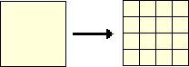

The area of the yellow square is 16 square units. That means, 16 square units are needed to cover the surface enclosed by the square.

**Real-world Connections for Area:**

The concept of area is very much used in real life. Designing your own apartments, rearranging the things in your room to get more space, designing your garden, etc. all these involve the amount of area you have to work with.

🞓🞓 Area under Curves 🞓🞓

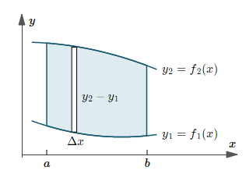

We want to find the area of the region formed by two curves, and two vertical lines. Consider the elementary rectangular area width is  and length is  .So the elementary area of the rectangle is.If we breaking the whole region into the rectangles and add up all areas then we get the total area of the bounded region.

Therefore 

If we impose the restriction limiting on  (that measure the width of elementary rectangle) as then we get the exact area of the bounded region.









**Therefore the area of the region formed by two curves, and two vertical lines is .**

**Note:**

1. The area of the region formed by two curves, and two horizontal linesis 



**d**

**c**

1. When the Inner function is x-axis the then area calculating formula is  where y is an Outer function.

**Mathematical Problems**

**Problem 01:** Determine the area of the region enclosed by  and.

Solution:

The equation of the given curves are  and.

The graph of the given curves are as follows:

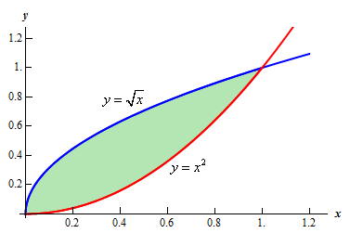

We have

 and

Now,



 [Squaring both sides]









Therefore  and 









For real we get respectively 

Therefore the given curves intersect each other in two point at and.

In the question, **.**

So, the area of the region is



















** Sq. Units. ( As desired)**

**Second Process:**

Solution:

The equation of the given curves are  and.

The graph of the given curves are as follows:



We have

 and

Now,



 [Squaring both sides]









Therefore  and 









For real we get respectively 

Therefore the given curves intersect each other in two point at and.

In the question, **.**

So, the area of the region is



















** Sq. Units. (As desired)**

**Note:** It is noted that when we calculate the area with respect to x or y axis we get the same result.

**Problem 02:** Obtain the area of the region enclosed by  and.

Solution:

The equation of the given curve is  and also the straight line is.

The graph of the given curve and straight lines are as follows:

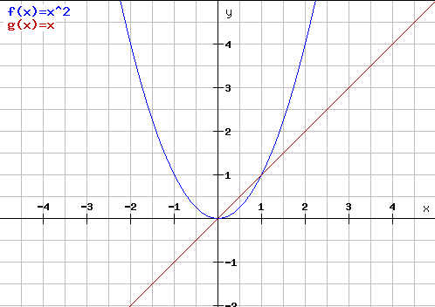

We have

 and 

Now,







Therefore 



For real we get respectively.

Therefore the given point of intersection of curve and straight lines are and.

In the question ,**.**

So, the area of the region is















** Sq. Units. (As desired)**

**Problem 03:** Determine the area of the region bounded by  and.

Solution:

The equation of the given curve is  and also the straight line is.

The graph of the given curve and straight lines are as follows:

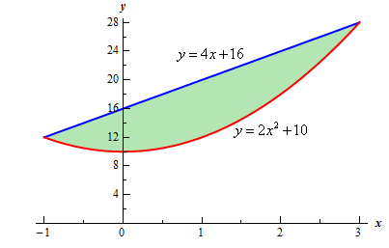

We have

 and 

Now,















Therefore 



For real we get respectively.

Therefore the given point of intersection of curve and straight lines are and.

In the question, **.**

So, the area of the region is























** Sq. Units. (As desired)**

**Problem 04 :** Determine the area of the region bounded by , ,.

Solution:

The equation of the given curve is  and also the straight lines are  , .

The graph of the given curve and straight lines are as follows:

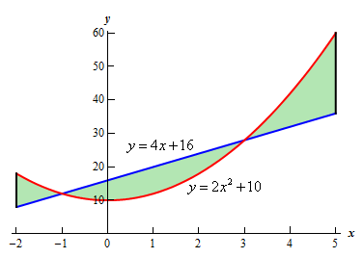

We have

 and 

Now,















Therefore 



For real we get respectively.

Therefore the given point of intersection of curve and straight lines are and.

Okay, we have a small problem here.  Our formula requires that one function always be the upper function and the other function always be the lower function and we clearly do not have that here.  However, this actually isn’t the problem that it might at first appear to be.  There are three regions in which one function is always the upper function and the other is always the lower function.  So, all that we need to do is find the area of each of the three regions, which we can do, and then add them all up.

In the question,  but our outer function is not same always.

Therefore the area is,













** Sq. Units (As desired)**

**Problem 05:** Determine the area of the region bounded by and.

Solution:

The equation of the given curve is  and also the straight line is.

The graph of the given curve and straight lines are as follows:

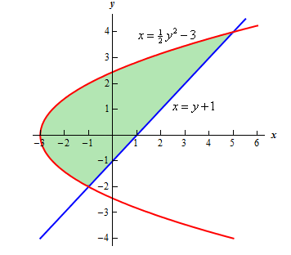

We have

 and 

Now,















Therefore 



For real we get respectively.

Therefore the given point of intersection of curve and straight lines are and.

In the question, **.**

So, the area of the region is















** Sq. Units (As desired)**

**Problem 06:** Determine the area of the region bounded by and the

y-axis.

Solution:

The equation of the given curves are and also the straight lines areand the y-axis.

The graph of the given curve and straight lines are as follows:

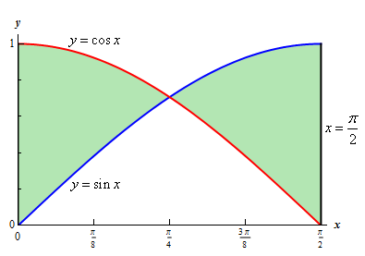

We have,



Now,











For real value  we get .

Therefore the point of intersection of given curves is .

In the question,  but our outer function is not same always.

So, the area of the region is





















** Sq. Units (As desired)**

**Problem 07:** Sketch the region bounded by  and .Find the area of the region.

Solution:

The equation of the given curve is  and also the straight line is.

The graph of the given curve and straight lines are as follows:

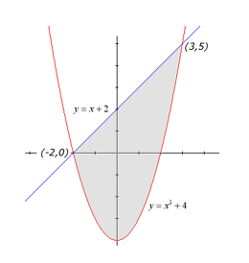

We have,

 and 

Now,











Therefore 



For real we get respectively.

Therefore the given point of intersection of curve and straight lines are and.

In the question, **.**

So, the area of the region is



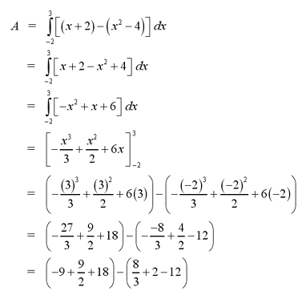

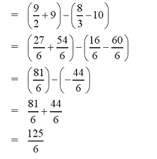

Therefore the area of the region enclosed by  and  is equal to sq. Units.

**(As desired)**

**Problem 08:** Sketch the region bounded by  ,  and .Find the area of the region.

Solution:

The equation of the given curve is  and also the straight lines are  and.

The graph of the given curve and straight lines are as follows:

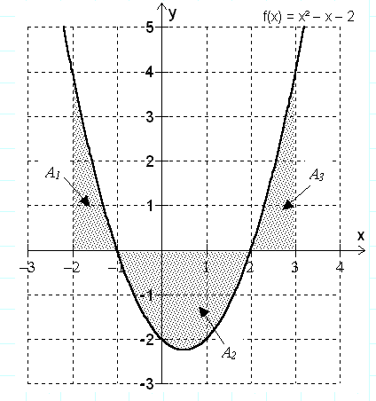

We have,

The equation of the curve is .Now finding intersecting points of the curves and x-axis.

Now,









Therefore 



Therefore the given point of intersection of curve and x-axis are and.

In the question, **.**

So, the area of the region is







Now,

















Again,

 [Negative sign is added since region under the y-axis]















And













Therefore the area of the enclosed region is







 sq. Units. **(As desired )**

**Problem 09:** Prove that the area of the circle isSq. Units.

Proof:

The equation of the circle is. Clearly the given equation represents a circle its Centre is in  and radius is “ a ” units.

The graph of the given circle is as follows:

**a**

We have,

The equation of the circle is .

Now,







In the question, **.**

So, the area of the region is

** [Since a circle have four symmetric part]**





Say  such that.

Limit:

When then .

When then.

Now,















** **









** Sq. Units (As desired )**

**Problem 10:** Prove that the area of the ellipse isSq. Units.

Proof:

The equation of the ellipse is. Clearly the given equation represents a ellipse its vertex is in , the length of major axis is “ 2a” and minor axis is “2b”.

The graph of the given ellipse is as follows:

**a**

We have,

The equation of the ellipse is.

Now,













In the question, **.**

So, the area of the region is

** [Since a ellipse have four symmetric part]**





Say  such that.

Limit:

When then .

When then.

Now,

















** **









** Sq. Units (As desired)**

**Try Yourself**

1. Find the area of the circle. Ans:  sq. units
2. Find the area of the ellipse. Ans:  sq. units
3. Find the whole area of the asteroid. Ans:  sq. units

Or Find the area of the asteroid.

Or Find the whole area of the asteroid.

1. Find the whole area of the cycloid . Ans:  sq. units
2. Find the area of the region bounded by parabola  and its latus rectum.

Ans:  sq. units

1. Find the area bounded by the parabolas and. Ans:  sq. units
2. Find the area of the circle. Ans:  sq. units
3. What is the entire area enclosed by the curve . Ans:  sq. units
4. Find the area of the hyperbola  bounded by x-axis and the ordinates.

Ans:  sq. units

1. Show that the area bounded by the parabola  and the coordinate axes is sq. units.
2. Find the area of the segment cut off from  by the line . Ans: Sq. units
3. Find the area bounded by the curves and . Ans:  sq. units
4. Find the area of the region enclosed by and .